1. Introduction :

The Movie Management System is a subscription-based application designed for movie enthusiasts. It offers a wide range of movies in its catalog, each characterized by various attributes such as ID, name, description, production date, age restriction, genre, and ratings.

The system caters to two types of users: admins and viewers. Both admins and viewers can access the system by logging in with their unique usernames and passwords.

Admins have additional privileges within the system. They can add movie details to the catalog and are responsible for managing user subscriptions. This includes keeping track of viewer subscriptions, handling renewals, and ensuring uninterrupted access to the movie catalog.

Viewers, on the other hand, can subscribe to the service, allowing them to watch movies from the extensive catalog. They can also provide ratings for movies they have watched, add movies to their personal showing list for future reference, and manage their subscriptions.

Overall, the Movie Management System aims to provide a seamless and enjoyable experience for movie enthusiasts, offering a vast collection of movies and convenient subscription management features.

1. **System hierarchy:**

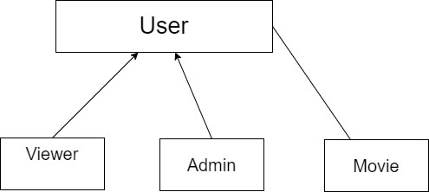

1. **UML class diagram:**
2. **Database schema**
3. **Snapshot of the execution trace**:



